IaC Provisioning for Real Estate System

Course Name: DevOps Foundations

Institution Name: Medicaps University – Datagami Skill Based Course

Student Name(s) & Enrolment Number(s):
Sr no | Student Name | Enrolment Number
1. | Vidhi Yadav | EN22CS3011077
2. | Suhani Pathak | EN22CS301990
3. | Surbhi Jadam | EN22CS3011002
4. | Vanshika Soni | EN22CS3011061
5. | Vinay | EN22CS3011082

Group Name: DO-07
Project Number: 07 D9
Industry Mentor Name: Mr. Vaibhav
University Mentor Name: Dr. Ritesh Joshi
Academic Year: 2026

Table of Contents

S.No. | Content
1. | Problem statement and objectives:
 | - Problem Statement
 | - Project Objectives
 | - Scope of the Project
2. | Proposed Solution
 | - Key features
 | - Overall Architecture/Workflow
 | - Tools and Technologies Used
3. | Results and Output
 | - Screenshots/Outputs
 | - Reports / dashboards / models
 | - Key outcomes
4. | Conclusion
5. | Future Scope and Enhancements

Problem Statement & Objectives

1. Problem Statement
Modern web applications require consistent, scalable, and secure infrastructure for deployment. Traditional manual setup of servers, databases, and runtime environments is:
- Time-consuming
- Error-prone
- Difficult to replicate across environments
- Hard to scale
For a Real Estate Web Application, ensuring consistent deployment across development, testing, and production environments is critical. Manual infrastructure provisioning increases the risk of configuration drift and deployment failures.
Therefore, there is a need to build a fully automated, containerized, and cloud-ready system using Infrastructure as Code (IaC), Docker, and CI/CD pipelines to ensure reliable and repeatable deployments.

2. Project Objectives
The key objectives of this project are:
- Automate infrastructure provisioning using Infrastructure as Code.
- Containerize the Real Estate application using Docker.
- Implement a CI/CD pipeline for automated build and deployment.
- Deploy the application on a cloud virtual machine.
- Ensure security, scalability, and performance.

- Maintain environment consistency across Dev, Test, and Production.
- Follow industry-standard DevOps practices.

3. Scope of the Project
The scope of the project includes:
- Development of a 3-tier Real Estate Web Application
- Containerization using Docker & Docker Compose
- Cloud deployment on AWS EC2
- Automated provisioning using Terraform / Ansible
- CI/CD pipeline using Jenkins
- Database design using MySQL
- Secure authentication using JWT
- Implementation of security and performance best practices

Proposed Solution
The proposed solution is a Containerized Real Estate Web Application deployed on AWS cloud, automated using Infrastructure as Code and CI/CD pipelines.
The solution consists of:
- React Frontend (UI Layer)
- Python Flask Backend (API Layer)
- MySQL Database (Data Layer)

- Docker-based containerization
- AWS EC2 for hosting
- Terraform for infrastructure provisioning
- Jenkins for CI/CD automation
This ensures:
- One-command deployment
- Cloud portability
- High reliability
- Easy scalability

1. Key Features
- Property listing & search functionality
- Add / Update / Delete property (Admin)
- Property detail view
- User registration & login (JWT-based authentication)
- Inquiry submission system
- Role-based access control (Admin/User)
- Containerized deployment
- Infrastructure as Code
- CI/CD automation
- Secure cloud deployment

2. Overall Architecture / Workflow
The system follows a 3-Tier Architecture:
- Presentation Layer – React (Vite) Frontend
- Application Layer – Python Flask REST API
- Data Layer – MySQL Database
All components are containerized using Docker and deployed on AWS EC2.

3. Tools & Technologies Used

Layer | Technology
Frontend | React (Vite)
Backend | Python Flask
Database | MySQL
Containerization | Docker
Orchestration | Docker Compose
Cloud | Amazon EC2
IaC | Terraform / Ansible
CI/CD | Jenkins
ORM | SQLAlchemy
Authentication | JWT + bcrypt

Results & Output

Application Successfully Deployed On:
- AWS EC2 Ubuntu Instance
- Publicly accessible via browser
- Docker containers running in detached mode

1. Screenshots / Outputs

8.1 Home Page



8.2 Property Detail Page

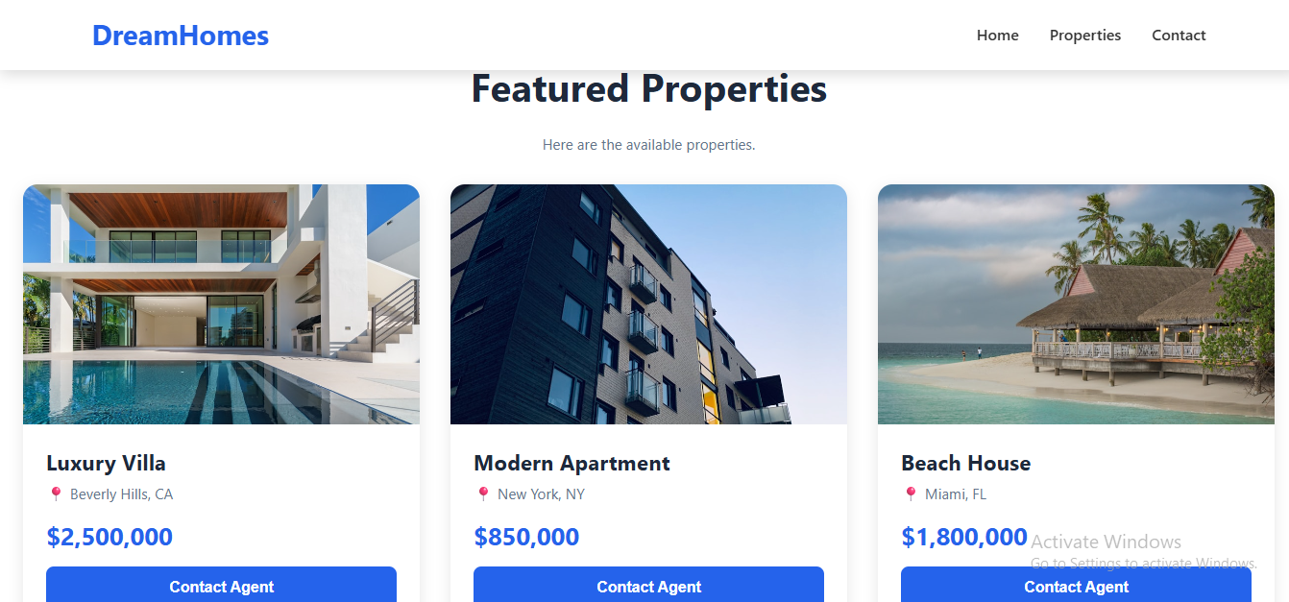

8.3 Contact Page

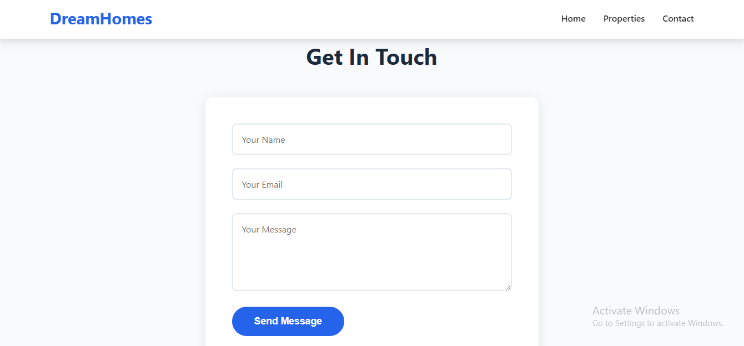

- Application Flow
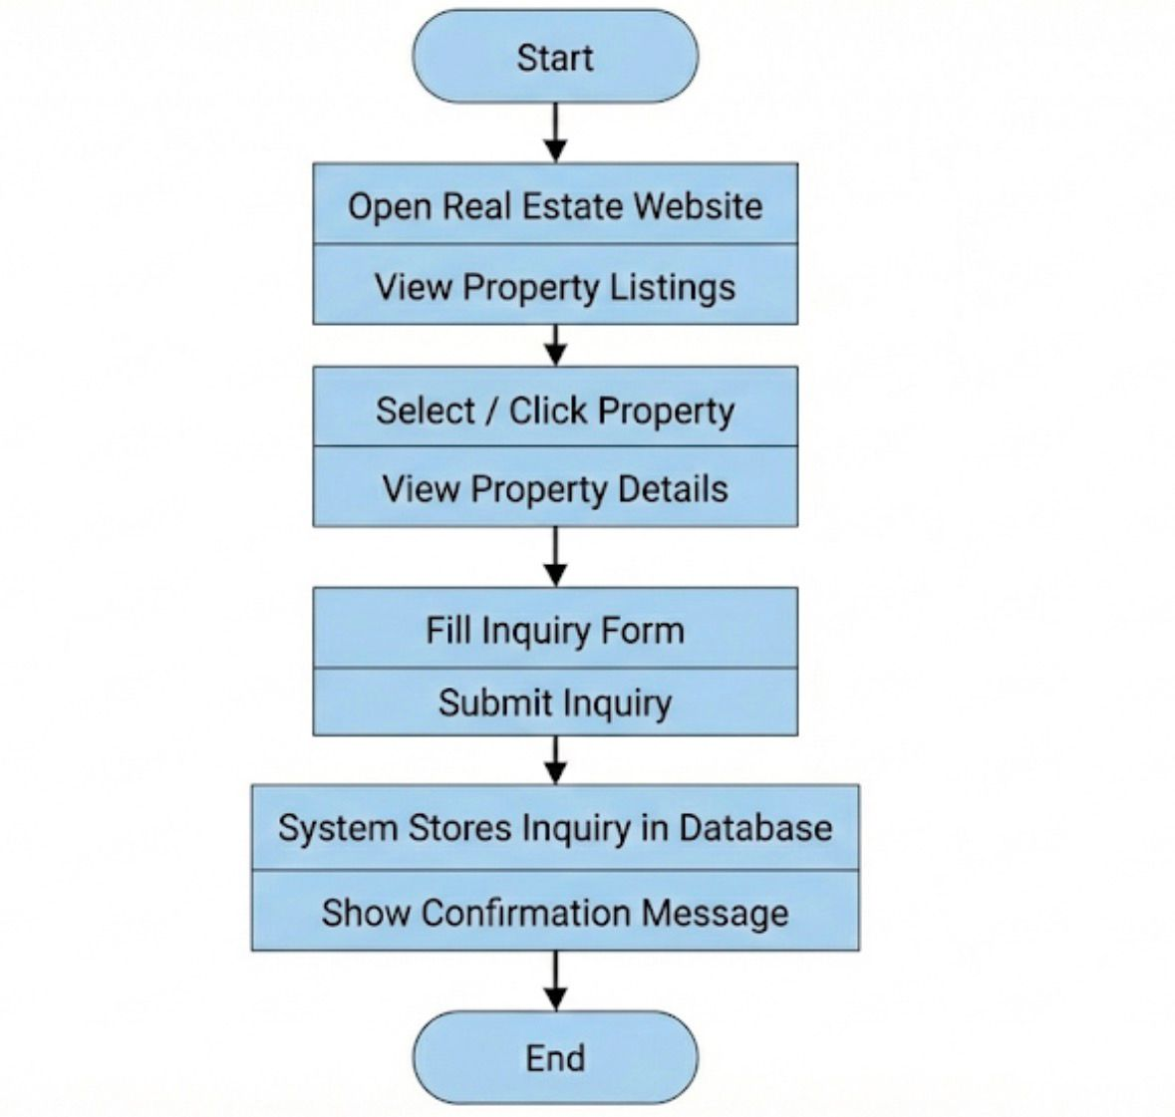

2. Reports / Dashboards / Models
- CI/CD Pipeline execution logs (Jenkins)
- Docker container status logs
- MySQL schema (ER Diagram)
- Terraform state management

3. Key Outcomes
- Fully automated infrastructure provisioning
- Reproducible deployment using Docker
- Secure JWT-based authentication

- Role-based authorization
- Scalable 3-tier architecture
- Cloud-ready DevOps implementation
- Zero manual server configuration

Conclusion
The IaC Provisioning for Real Estate System successfully demonstrates how modern DevOps practices can transform traditional application deployment into a fully automated, scalable, and secure pipeline.
By integrating:
- Infrastructure as Code
- Containerization
- CI/CD automation
- Cloud deployment
The project eliminates manual configuration errors and ensures consistency across environments.

Key Learnings:
- Practical implementation of 3-tier architecture
- Hands-on experience with Docker & cloud deployment
- Infrastructure automation using Terraform
- CI/CD pipeline design
- Secure authentication using JWT

- Real-world DevOps workflow
This project bridges the gap between development and operations, showcasing industry-ready deployment practices.

Future Scope & Enhancements
The system can be enhanced with:
- AWS Load Balancer integration
- Auto Scaling Groups
- Redis caching implementation
- Refresh token mechanism
- Monitoring & alerting using CloudWatch
- Blue-Green deployment strategy
- Microservices architecture expansion

